Download:
sudo apt-get install ros-kinetic-multimaster-fkie

网络配置：已两台电脑为例 ：一台是robot（nuc），另一台是laptop

1、修改 /etc/hosts
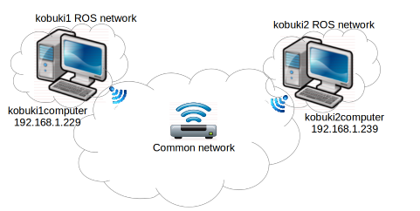

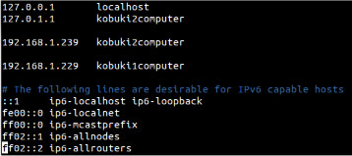

both computer configure
Change the ROS_MASTER_URIvariable:

必须在控制台分别输入当前电脑的ip address
export ROS_MASTER_URI=http://<hostname or IP address>:11311

控制台输入：
source .bashrc

Enable multicast:

cat /proc/sys/net/ipv4/icmp_echo_ignore_broadcasts

return 0 多播功能启动

sudo sh -c "echo 0 >/proc/sys/net/ipv4/icmp_echo_ignore_broadcasts"
临时启动多播功能

永久启用多播功能

进入etc/sysctl.conf

net.ipv4.icmp_echo_ignore_broadcasts=0

添加之后，使用
sudo service procps restart

netstat -g 查看多播地址
The standard IP address for multicast is 224.0.0.1,that should appear on the list provided by the last command, and it is the one we will use.

Ping 224.0.0.1
(my 224.0.0.251)

test:
所有电脑
roscore
rosrun master_discovery_fkie master_discovery _mcast_group:=224.0.0.1
rosrun master_sync_fkie master_sync

执行下列指令获得所有master：
rosservice call /master_discovery/list_masters

